Exo 1 :

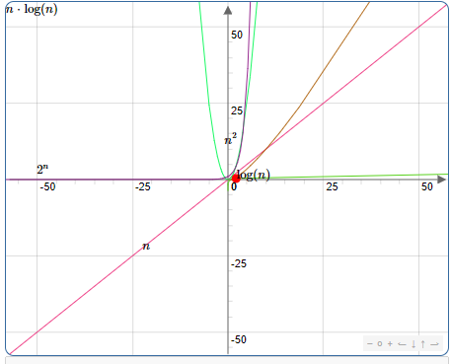

Exo2 :

temps necessaire a une instruction: 10^-7

nombre d'instruction : n

instruction en 1 sec : 10^-7n

10^-7n = 1

n = 1/10^-7

instruction en 60 sec : 10^-7n

10^-7n = 60

n = 60/10^-7

instruction en 3600 sec : 10^-7n

10^-7n = 3600

n = 3600/10^-7

instruction en 86400 sec : 10^-7n

10^-7n = 86400

n = 86400 /10^-7

---------------------------------------------------------------------------------------------------------------

nombre d'instruction : n^2

instruction en 1 sec : 10^-7n^2

10^-7n^2 = 1

n = √(1/10^-7)

instruction en 60 sec : 10^-7n^2

10^-7n^2 = 60

n = √(60/10^-7)

instruction en 3600 sec : 10^-7n^2

10^-7n^2 = 3600

n = √(3600/10^-7)

instruction en 86400 sec : 10^-7n^2

10^-7n^2 = 86400

n = √(86400 /10^-7)

----------------------------------------------------------------------------------------------------------------

nombre d'instruction : 2^n

instruction en 1 sec : 10^-7\*(2^n)

10^-7(2^n) = 1

2^n = 1/10^-7

log2(2^n) = log2(1/10^-7)

n = log2(1/10^-7)

nombre d'instruction : 2^n

instruction en 60 sec : 10^-7\*(2^n)

10^-7(2^n) = 60

2^n = 60/10^-7

log2(2^n) = log2(60/10^-7)

n = log2(60/10^-7)

nombre d'instruction : 2^n

instruction en 3600 sec : 10^-7\*(2^n)

10^-7(2^n) = 3600

2^n = 3600 /10^-7

log2(2^n) = log2(3600 /10^-7)

n = log2(3600 /10^-7)

instruction en 86400 sec : 10^-7\*(2^n)

10^-7(2^n) = 86400

2^n = 86400 /10^-7

log2(2^n) = log286400 /10^-7)

n = log2(86400 /10^-7)

----------------------------------------------------------------------------------------------------------------

nombre d'instruction : log(n)

instruction en 1 sec : 10^-7\*log(n)

10^-7log(n) = 1

log(n) = 1/10^-7

10log(n) = 10(1/10^-7)

n = 10 (1/10^-7)

instruction en 60 sec : 10^-7\*log(n)

10^-7log(n) = 60

log(n) = 60/10^-7

10log(n) = 10(60/10^-7)

n = 10 (60/10^-7)

instruction en 3600 sec : 10^-7\*log(n)

10^-7log(n) = 3600

log(n) = 3600/10^-7

10log(n) = 10(3600/10^-7)

n = 10 (3600/10^-7)

instruction en 86400 sec : 10^-7\*log(n)

10^-7log(n) = 86400

log(n) = 86400 /10^-7

10log(n) = 10(86400 /10^-7)

n = 10 (86400 /10^-7)

----------------------------------------------------------------------------------------------------------------

nombre d'instruction : n log(n)

n = 1/10^-7

log(n) = 1/10^-7

n log(n) = (1/10^-7) \* (1/10^-7)

exo 3 :